

**Nerf Madness Handout**

**Idea’s for themed activities**

**&**

**Blasters to acquire**

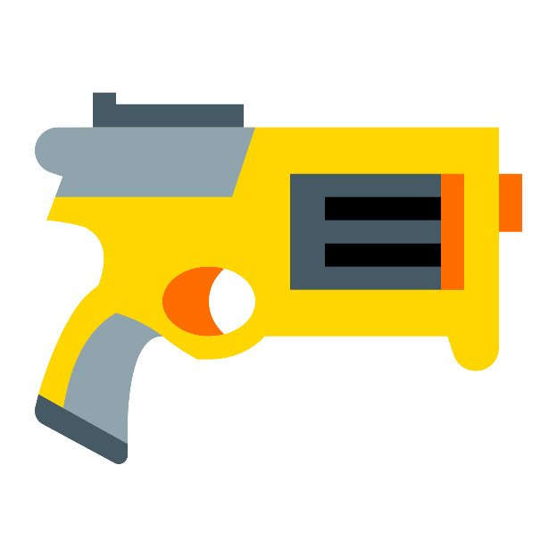

Zombies

Turkey Shoot

Deer Hunting

Biathlon

Star Trek Day

Star Wars Day

Archery Day

Nerf Blasters

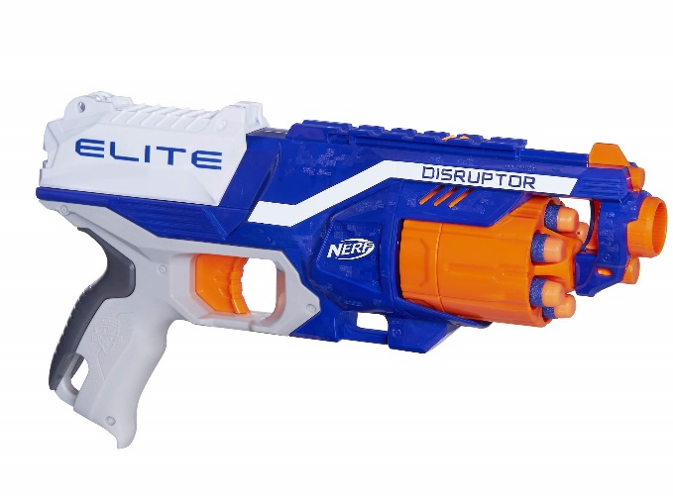 Nerf Disruptor Elite

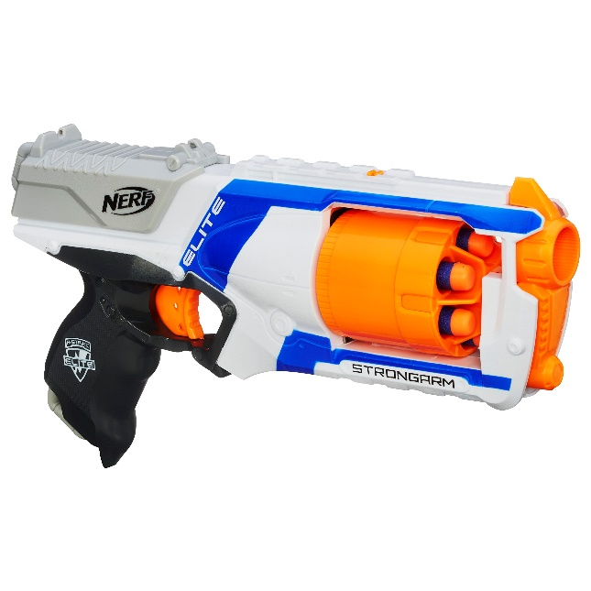 Nerf Elite Strongarm

Nerf Elite 2. 0 Eagle Point

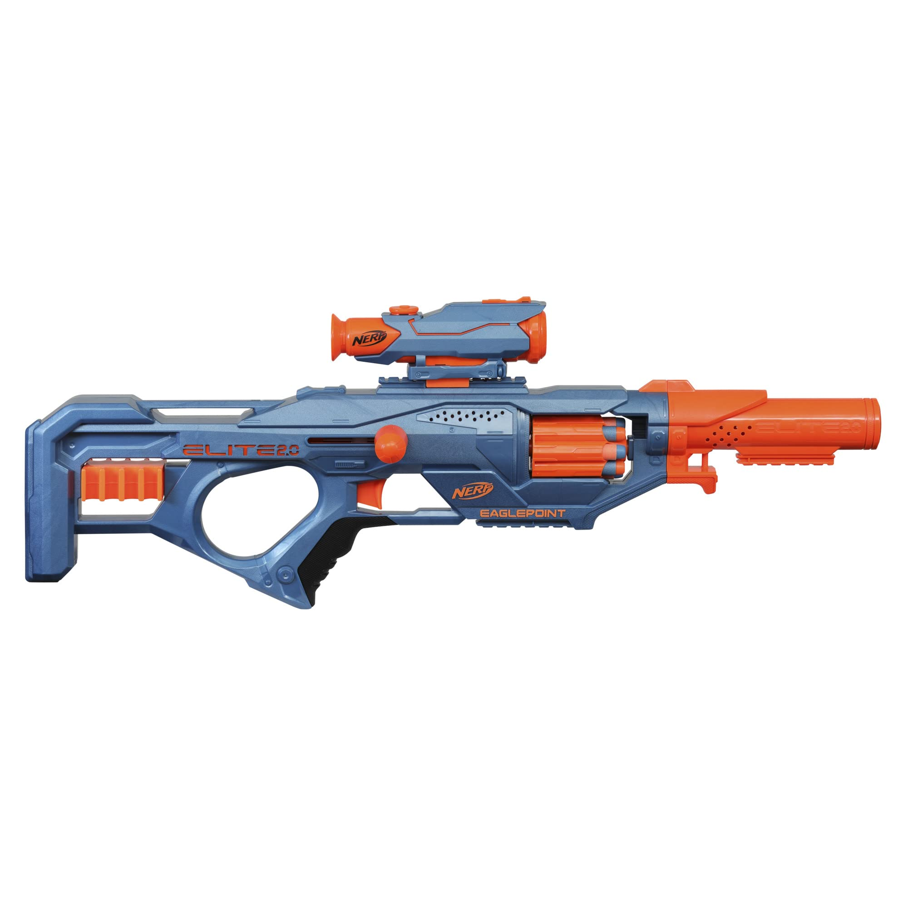

**Additional Resource**

[Coop772 - YouTube](https://www.youtube.com/@Coop772)

